Safeguarding Children Policy – AND Oxfordshire LTD

- Introduction
1.1 AND Oxfordshire LTD (“the Company”) is fully committed to safeguarding and protecting the welfare of all children (defined as a person under the age of 18 years) under its service
1.2 The Company has a duty to act appropriately in regards to suspicion or disclosures of abuse, including any allegations towards staff, directors, volunteers and contractors of the Company
1.3 The Company keeps children safe by providing a setting where they feel listened to and respected
1.4 The Company believes that all children, regardless of age, ability, gender, racial heritage, religious or spiritual beliefs, sexual orientation and /or identity, have the right to equal protection from harm or abuse
1.4 The Company recognises that some children are additionally vulnerable because of the impact of previous experiences, their level of dependency, communication needs or other issues
1.5 The Company works in partnership with Oxfordshire Safeguarding Children Board (OSCB) and other relevant agencies to safeguard children
1.6 All staff, directors, volunteers and contractors of the Company are expected to understand and follow this policy

- Roles and Responsibilities
2.1 The Company has a Designated Safeguarding Lead (DSL; Name, Work Mobile, Work Email) who must be contacted in all situations where abuse is suspected or disclosed
2.2 The Company has a Deputy DSL (Name, Work Mobile, Work Email) who must be contacted in situations where the DSL is unavailable, and abuse is suspected or disclosed
2.3 The DSL and Deputy DSL are expected to be trained to their required level (Level 3: Designated Safeguarding Lead) by OSCP every two years
2.4 All directors and youth groups leaders are expected to be trained to their required level (Level 3: Designated Safeguarding Lead) by OSCP every two years, even if they are not currently DSL or Deputy DSL
2.5 All support workers are expected to be trained to their required level (Level 2: Generalist Safeguarding) by OSCP every three years
2.6 All volunteers are expected to be trained to their required level (Level 1: Introduction to Safeguarding) by OSCP every three years
2.7 All staff, directors, volunteers and contractors of the Company are expected to store data relating to suspected or disclosed abuse in line with the Company’s Data Protection Policy
2.8 The Company is responsible for adopting safe recruitment and selection procedures for new staff, directors, volunteers and contractors
2.9 The Company will review this policy annually to appraise their safeguarding practice against OSCB standards and ensure it aligns with UK Law

- Internal Procedures
3.1 For support workers and volunteers, all safeguarding concerns occurring during youth group sessions should be discussed immediately with the youth group leader
3.2 In the case that the youth group leader is not DSL, the youth group leader must immediately contact the DSL (or Deputy DSL if the DSL is not available)
3.3 It is the responsibility of the DSL or Deputy DSL to decide whether there is an immediate safeguarding concern and in the case that there is, to make a referral to the Emergency Duty Team (0800 833 408) as youth group runs out of the Multi-Agency Safeguarding Hub (MASH; 03450 507666) hours
3.4 If the DSL or Deputy DSL has concerns that do not require an immediate safeguarding response, they are responsible for contacting the Locality and Community Support Service (LCSS; 03452 412705, LCSS.Central@oxfordshire.gov.uk)
3.5 If a director, staff member, volunteer, or contractor has a concern relating to harm or potential harm to a child by a director, staff member, volunteer, or contactor, they must either contact the DSL or if the concern relates to the DSL, the deputy DSL
3.6 The DSL or deputy DSL is responsible for reporting concerns relating to a director, staff member, volunteer, or contractor to the Local Authority Designated Officer (LADO; 01865 810603, LADO.safeguardingchildren@oxfordshire.gov.uk)
3.7 Unless it would place the child at an increased risk of harm, the child’s parents/carers should be contacted by the DSL or Deputy DSL to discuss the concern and what action has been/will be taken
3.8 A safeguarding report should be completed in all cases of that there is a safeguarding concern and it is the responsibility of the DSL or Deputy DSL to ensure it is completed within 48 hours of the concern being raised
3.8 The DSL or Deputy DSL is also responsible for ensuring support for staff following a concern or disclosure
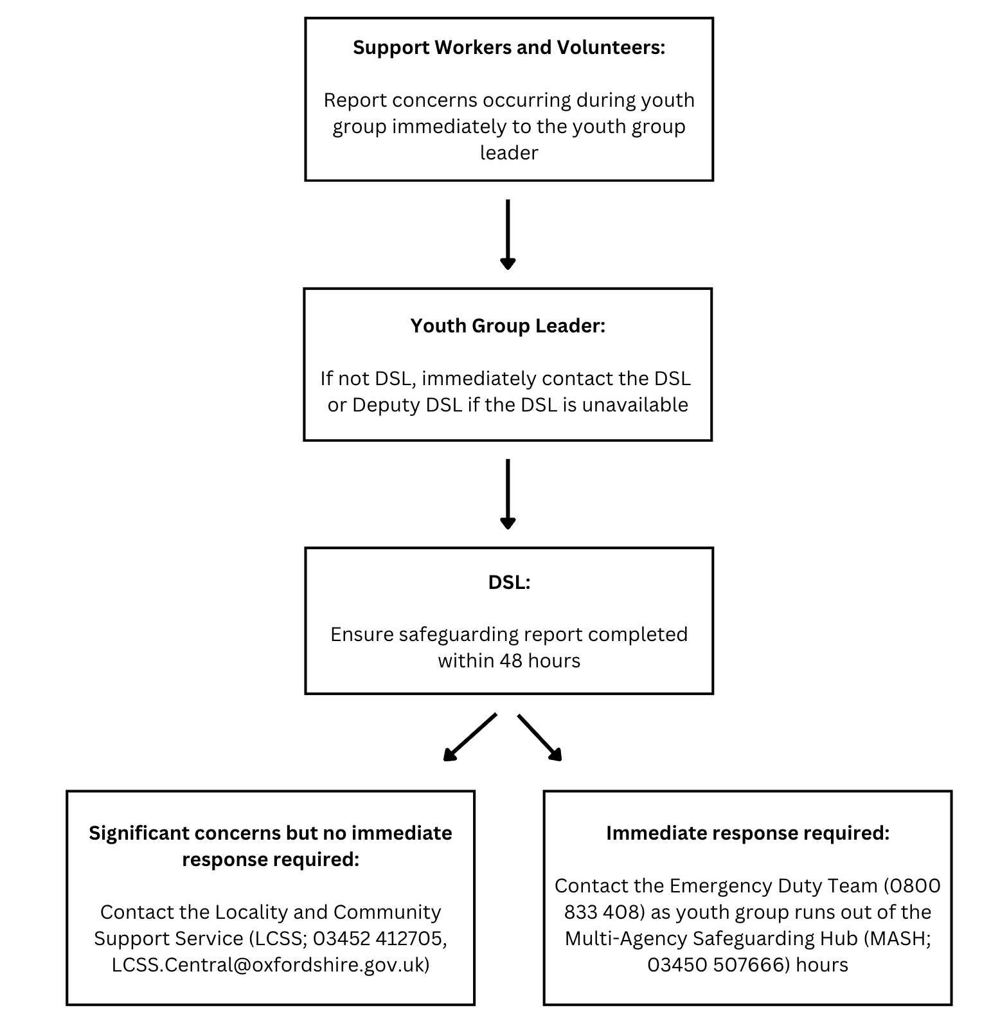

Appendix

Legal Framework
- Children Act 1989
- United Nations Convention on the Rights of the Child 1991
- Children Act 2004
- Equality Act 2010
- Children and Families Act 2014
- Special educational needs and disability (SEND) code of practice: 0 to 25 years
- What to do if you are worried a Child is being Abused 2015
- Working Together to Safeguard Children 2018
- Keeping Children Safe in Education 2022
- Oxfordshire Safeguarding Children Board guidelines

Definitions and Indicators of Abuse

The table below outlines the main categories of abuse as defined by the Department of Health ‘Working Together to Safeguard Children 2018’ document. (Full definitions can be found in this document). All staff should be aware that the possible indicators are not definitive and that some children may present these behaviours for reasons other than abuse.

Type of Abuse | Possible Indicators
Neglect  The persistent failure to meet a child's basic physical and/or psychological needs, likely to result in the serious impairment of the child's health or development. Neglect may occur during pregnancy as a result of maternal substance abuse. Once a child is born, neglect may involve a parent or carer failing to:  - provide adequate food, clothing and shelter (including exclusion from home or abandonment);  - protect a child from physical and emotional harm or danger;  - ensure adequate supervision (including the use of inadequate caregivers); or  - ensure access to appropriate medical care or treatment.  It may also include neglect of, or unresponsiveness to, a child's basic emotional needs. | Signs that may indicate a child is living in a neglectful situation:  - excessive hunger  - poor personal hygiene  - frequent tiredness  - inadequate clothing  - frequent lateness or non-attendance at school  - untreated medical problems  - not brought  - poor relationships with peers  - compulsive stealing and scavenging  - rocking, hair twisting and thumb sucking  - running away  - loss of weight or being constantly underweight (the same applies to weight gain, or being excessively overweight  - low self esteem  - poor dental hygiene
Physical Abuse  May involve hitting, shaking, throwing, poisoning, burning or scalding, drowning, suffocating or otherwise causing physical harm to a child. Physical harm may also be caused when a parent or carer fabricates the symptoms of, or deliberately induces illness in a child. | Signs that may indicate physical abuse:  - Physical signs that do not tally with the given account of occurrence,  - conflicting or unrealistic explanations of causer  - repeated injuries  - delay in reporting or seeking medical advice.
Sexual Abuse  Involves forcing or enticing a child or young person to take part in sexual activities, not necessarily involving a high level of violence, whether the child is aware of what is happening.  The activities may involve physical contact, including assault by penetration (for example, rape or oral sex) or non-penetrative acts such as masturbation, kissing, rubbing and touching outside of clothing.  They may also include non-contact activities, such as involving children in looking at, or in the production of, sexual images, watching sexual activities, encouraging children to behave in sexually inappropriate ways, or grooming a child in preparation for abuse (including via the internet).  Sexual abuse is not solely perpetrated by adult males. Women can also commit acts of sexual abuse, as can other children. | Signs that may indicate sexual abuse:  Changes in:  - Behaviour  - Language  - Social interaction  - Physical wellbeing  It is almost important to recognise there may be no signs.
Emotional Abuse  The persistent emotional maltreatment of a child such as to cause severe and persistent adverse effects on the child's emotional development.  It may involve conveying to a child that they are worthless or unloved, inadequate, or valued only insofar as they meet the needs of another person. It may include not giving the child opportunities to express their views, deliberately silencing them or 'making fun' of what they say or how they communicate.  It may feature age or developmentally inappropriate expectations being imposed on children. These may include interactions that are beyond a child's developmental capability, as well as overprotection and limitation of exploration and learning, or preventing the child participating in normal social interaction  It may involve seeing or hearing the ill-treatment of another. It may involve serious bullying (including cyber bullying), causing children frequently to feel frightened or in danger, or the exploitation or corruption of children.  Some level of emotional abuse is involved in all types of maltreatment of a child, though it may occur alone. | Signs that may indicate emotional abuse:  - Lack of self-confidence/esteem  - Sudden speech disorders  - Self-harming (including eating disorders)  - Drug, alcohol, solvent abuse  - Lack of empathy (including cruelty to animals)  - Concerning interactions between parent/carer and the child (e.g., excessive criticism of the child or a lack of boundaries)

Other safeguarding concerns you should be aware of

Child Exploitation

Child Exploitation’ is the deliberate maltreatment, manipulation or abuse of power and control over a child aged under 18. It is taking advantage of another person or situation usually, but not always, for personal gain.
Exploitation comes in many forms, including, but not limited to:
- Child Sexual Exploitation
- Child Drug Exploitation (CDE)
- Human trafficking – including intra and international trafficking
- Modern Slavery, including domestic servitude

Child Sexual Exploitation (CSE)

Child sexual exploitation is a form of child sexual abuse.

It occurs where an individual or group takes advantage of an imbalance of power to coerce, manipulate or deceive a child or young person under the age of 18 into sexual activity (a) in exchange for something the victim needs or wants, and/or (b) for the financial advantage or increased status of the perpetrator or facilitator.

The victim may have been sexually exploited even if the sexual activity appears consensual. Child sexual exploitation does not always involve physical contact; it can also occur through the use of technology.

Signs that may indicate CSE:
- Going missing from school/home/care placement
- Associating with older people/adults
- Isolation from family/friends/peer group
- Physical symptoms including bruising/STI’s
- Substance misuse
- Mental health
- Unexplained possessions, goods and/or money

Child Drug Exploitation

Child Drug Exploitation describes how gangs from large urban areas supply drugs to suburban and rural locations, using vulnerable children and young people to courier drugs and money.

Typically, gangs use mobile phone lines to facilitate drug orders and supply to users. They also use local property as a base; these often belong to a vulnerable adult and are obtained through force or coercion (this exploitation is sometimes referred to as ‘cuckooing’).

Gangs ‘recruit’ through deception, intimidation, violence, debt bondage and/or grooming into drug use and/or child sexual exploitation.

While there has been an increased awareness of the use of children and young people in county line markets, more needs to be done as it cuts across a number of issues such as drug dealing, violence, gangs, child sexual exploitation, safeguarding, modern slavery and missing persons.

Signs that may indicate drug/criminal exploitation are similar to CSE, as follows:
- Going missing from school/home/care placement
- Associating with older people/adults
- Isolation from family/friends/peer group
- Physical symptoms including bruising
- Substance misuse
- Mental health
- Unexplained possessions, goods and/or money

Modern Slavery and Human Trafficking

Modern slavery can take many forms including the trafficking or people, forced labour, servitude and slavery. Victims can include adults and children and come from all walks of life and backgrounds. A quarter of all victims are children.

The Modern Slavery Act 2015 places a duty on specified public authorities to report details of suspected cases of modern slavery to the National Crime Agency.

Indicators of Modern Slavery can include:
- Lack of access to legal documents (e.g., passports)
- Appearance (malnourished, unkempt, etc)
- Untreated or unexplained injuries
- Attitude (withdrawn, frightened, unable to speak for themselves)
- Indebtedness or in a situation of dependence
- Frequent changes of location or restrictions on movement

Domestic Abuse

Defined as, “Any incident or pattern of incidents of controlling, coercive or threatening behaviour, violence or abuse between those aged 16 or over who are or have been intimate partners or family members regardless of gender or sexuality. This can encompass but is not limited to the following types of abuse: psychological, physical, sexual, financial or emotional”.

Forced marriage

A forced marriage is a marriage conducted without the valid consent of one or both parties and where duress is a factor. Forced marriage is now a specific offence under s121 of the Anti-Social Behaviour, Crime and Policing Act 2014 that came into force on 16 June 2014.

Forced marriage is very different to an arranged marriage where both parties give consent.

Female Genital Mutilation

Female genital mutilation (FGM), sometimes referred to as female circumcision or cutting, refers to procedures that intentionally alter or cause injury to the female genital organs for non-medical reasons. The practice is illegal in the UK.

There are no health benefits to FGM, it is carried out for cultural and social reasons within families and communities. The procedure is traditionally carried out by an older woman with no medical training. Anaesthetics and antiseptic treatment are not generally used and the practice is usually carried out using basic tools such as knives, scissors, scalpels, pieces of glass and razor blades.

Healthcare professionals have a duty to safeguard any children who may be at risk of FGM. Information about how to identify children at risk of FGM, including a screening tool and pathways are available on the Oxfordshire Safeguarding Children Board website.

Mental health and wellbeing

Mental health conditions have become more common among children and young people. Among those aged 6 to 16 in England, one in six had a probable mental health condition in 2021, up from one in nine in 2017. Current figures are especially concerning for adolescent girls aged between 17 and 19: one in four had a probable mental health condition in 2021.

CAMHS Oxfordshire support children and young people with emotional, behavioural and mental health difficulties, for further information on services and referral within Oxfordshire see here CAMHS website

Self-Harm

Deliberate self-harm is intentional self-poisoning or injury, irrespective of the apparent purpose of the act, (www.nice.org.uk). Self-harm is an expression of personal distress, not an illness.

Self-harm can involve:
- Cutting, burning, biting
- Substance misuse
- Head banging and hitting
- Taking personal risk
- Picking and scratching
- Self-neglect
- Pulling out hair
- Disordered eating
- Overdosing and self-poisoning

Indicators of self-harm may include:
- Changing in eating/sleeping habits
- Lowering of academic grades
- Changes in activity and mood
- Abusing drugs or alcohol
- Increased isolation from friends and family
- Becoming socially withdrawn
- Talking about self-harming or suicide
- Giving away possessions
- Expressing feelings of failure, uselessness or loss of hope

Disordered Eating

While disordered eating can affect anyone of any age, young people are at particular risk.
Through the COVID-19 pandemic, a lot of services have noticed an increase in children and young people requesting support in relation to eating problems. Controlling what they eat has been a way of managing anxiety during these difficult times.
CAMHS Eating Disorders Service provides information for young people, families and professionals, where there is concern that a young person may have an eating disorder, and support for young people with eating disorders. To download a leaflet on the service, follow this link: Information about the Eating Disorders Service for young people and their families, visit the CAMHS website or find information and resources on the BEAT website.

Bullying

Bullying is not always easy to recognise as it can take a number of forms. A child may encounter bullying attacks that are:
- Physical: pushing, kicking, hitting, pinching and other forms of violence or threats
- Verbal: name-calling, sarcasm, spreading rumours, persistent teasing
- Emotional: excluding. tormenting, ridiculing, humiliating

Persistent bullying can result in depression, low self-esteem, shyness, poor academic achievement, isolation, threatened or attempted suicide

Indicators a child is being bullied can be:
- coming home with cuts and bruises
- torn clothes
- asking for stolen possessions to be replaced
- losing dinner money
- falling out with previously good friends
- being moody and bad tempered
- wanting to avoid leaving their home
- aggression with younger brothers and sisters
- doing less well at school
- sleep problems
- anxiety
- becoming quiet and withdrawn

Child on Child Abuse

Child-on-child abuse is any form of physical, sexual, emotional and financial abuse, and coercive control, exercised between children and within children's relationships (both intimate and
non-intimate).

Child-on-child abuse can take various forms, including: serious bullying (including cyber-bullying), relationship abuse, domestic violence, child sexual exploitation, youth and serious youth violence, harmful sexual behaviour, and/or gender-based violence.

Elective Home Education

Parents are entitled to remove their children from school rolls for the purposes of elective home education (EHE). However, there is no professional oversight, funding or provision to support children and parents when this step is taken. There is also no guarantee that the child can return to the original school if parent cannot cope with the extent of the home educating commitment.

Whilst parents who choose elective home education are no more likely to abuse their children than the general population, safeguarding reviews have highlighted the challenges facing professionals who may not have a full understanding of the rights of parents who choose this form of education.

Reviews also identify, that in some cases, elective home education can lead to the isolation and invisibility of children, through parental avoidance of services which could monitor their children’s health, development, and wellbeing.

This 1-minute guide to education provides information and guidance for non-education professionals on children and parents right in relation to education and what to do should they have concerns that a child is not receiving their educational entitlement.

Prevent - Extremism

The Counterterrorism and Security Act 2015 places a safeguarding duty on settings to have “due regard to the need to prevent people from being drawn into terrorism”.

Settings subject to the Prevent Duty will be expected to demonstrate activity in the following areas:
- Assessing the risk of children being drawn into terrorism
- Demonstrate that they are protecting children and young people from being drawn into terrorism by having robust safeguarding policies.
- Ensure that their safeguarding arrangements take into account the policies and procedures of the Local Safeguarding Children Board.
- Make sure that staff have training that gives them the knowledge and confidence to identify children at risk of being drawn into terrorism, and to challenge extremist ideas which can be used to legitimise terrorism
- Ensure children are safe from terrorist and extremist material when accessing the internet in the setting

Preventing vulnerable adults and children from being drawn into extremism is a safeguarding concern. It is essential that frontline staff can spot the signs and make a safeguarding referral.

Indicators may include:
- Withdrawing from usual activities
- Accessing extremist literature/websites
- Expressing ‘us and them’ thinking
- Expressing feelings of anger, grievance, or injustice

